**Lab #1: Programming Exercise**

Before starting Visual Studio 2012 be sure that you have created a folder in which to store your CS 1400 project folders and associated files. Now, start up Visual Studio on your computer. Start a new Console Project. The new project dialogue shows you the location where your files will be stored by default. Change this location to point to the folder that you just created for this project. Immediately save it in the folder that you created for your CS1400 assignments.

In the Visual Studio code editing window that has been created, type in the lines of C# source code shown below. Pay attention to the spacing and indentation used in the code. You should substitute your own name and course information where appropriate. When you are done, save the source code file in the folder that you have prepared.

// File Prologue  
// Name: <--- be sure to add your name here  
// Project: lab01"  
// Date: <---- add today's date  
  
   
// I declare that the following source code was written by me, or provided  
// by the instructor for this project. I understand that copying   
// source code from any other source constitutes cheating, and that I will  
// receive a zero grade on this project if I am found in violation of  
// this policy.  
  
   
using System;  
  
   
static class Program  
{  
   static void Main()  
   {  
      // This program displays my student information  
      string name = "your name";  
      string course = "CNS 1400";  
      string section = "your section";  
      string project = "Lab One";  
  
   
      // This code displays the strings on the console  
      Console.WriteLine("Name: {0}", name);  
      Console.WriteLine("Course: {0}", course);  
      Console.WriteLine("Section: {0}", section);  
      Console.WriteLine("Project: {0}", project);  
  
   
      Console.ReadLine();  
   }// End Main  
} // End Class Program

Now you will compile and your program. If you get errors when compiling, look back over the code you have entered, and make sure that it exactly matches what is shown here. Once you have a successful build, execute your program. You should see a DOS Console window open up that looks something like the following. Remember that the information displayed must be yours, not what you see in the example shown here.

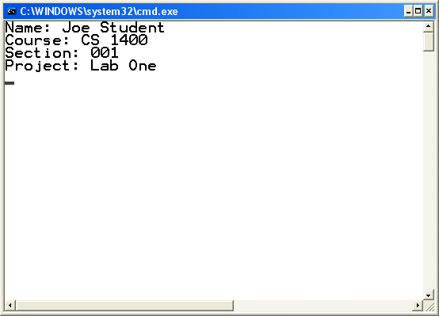

To close this window, press the Enter key. If things went well, you have successfully created, compiled, and executed your first C# program.

**File(s) to Submit:**

To submit your assignment place the entire project folder in a zip file and name the zip file  
lab_01_your-initials_V1.0.zip. For example, I would name my file lab_01_RKD_V1.0.zip. Submit the assignment as Lab #1 on Canvas.

**Grading Guidelines**

|  |  |
| --- | --- |
| **Description** | **Points possible** |
|  |  |
| Assignment meets grading guidelines:  o Source code files contain a declaration that you did not copy any code, except that provided.  o Program has been properly submitted to Canvas  o Code meets style guidelines  o Code contains a Console.ReadLine( ) as the last statement | 2 |
| Program executes correctly, and meets the specification. | 3 |
| Total | 5 |